**DAV EXPERIMENT 3**

# Sample data

Y = [-3.7, 3.5, 2.5, 11.5, 5.7]

X1 = [3, 4, 5, 6, 2]

X2 = [8, 5, 7, 3, 1]

# Calculate the coefficients (beta values) - same as before

mean_X1 = sum(X1) / len(X1)

mean_X2 = sum(X2) / len(X2)

mean_Y = sum(Y) / len(Y)

beta1 = sum((X1[i] - mean_X1) * (Y[i] - mean_Y) for i in range(len(X1))) / sum((X1[i] - mean_X1) ** 2 for i in range(len(X1)))

beta2 = sum((X2[i] - mean_X2) * (Y[i] - mean_Y) for i in range(len(X2))) / sum((X2[i] - mean_X2) ** 2 for i in range(len(X2)))

beta0 = mean_Y - beta1 * mean_X1 - beta2 * mean_X2

# New values for prediction

new_X1 = 3

new_X2 = 2

# Predict Y for new values of X1 and X2

predicted_Y = beta0 + beta1 * new_X1 + beta2 * new_X2

# Print the predicted Y

print("Y = a + β1X1 + β2X2")

print(f"Y = {beta0} + {beta1} * X1 + {beta2} * X2")

print("Predicted Y for new values of X1 and X2:", predicted_Y)

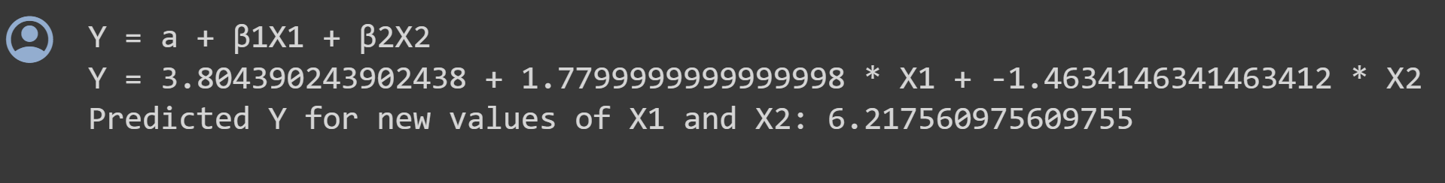

# Sample data

Y = [-3.7, 3.5, 2.5, 11.5, 5.7]

X1 = [3, 4, 5, 6, 2]

X2 = [8, 5, 7, 3, 1]

# New data for prediction

new_x1 = 3

new_x2 = 2

# Number of data points

n = len(X1)

# Calculate the means

mean_x1 = sum(X1) / n

mean_x2 = sum(X2) / n

mean_y = sum(Y) / n

# Calculate the coefficients

numerator1 = sum((X1[i] - mean_x1) * (Y[i] - mean_y) for i in range(n))

denominator1 = sum((X1[i] - mean_x1) ** 2 for i in range(n))

beta1 = numerator1 / denominator1

numerator2 = sum((X2[i] - mean_x2) * (Y[i] - mean_y) for i in range(n))

denominator2 = sum((X2[i] - mean_x2) ** 2 for i in range(n))

beta2 = numerator2 / denominator2

a = mean_y - beta1 * mean_x1 - beta2 * mean_x2

print("Intercept a =", a)

print("β1 =", beta1)

print("β2 =", beta2)

print("Estimate X1 =", new_x1)

print("Estimate X2 =", new_x2)

print("\n")

# Make predictions for new values

new_y = a + beta1 * new_x1 + beta2 * new_x2

print("Y = a + β1X1 + β2X2")

print(f"Y = {a} + {beta1} * X1 + {beta2} * X2")

# Make predictions for new values

new_y = a + beta1 * new_x1 + beta2 * new_x2

print("\n")

print("Predicted y for new X1 and X2:", new_y)

